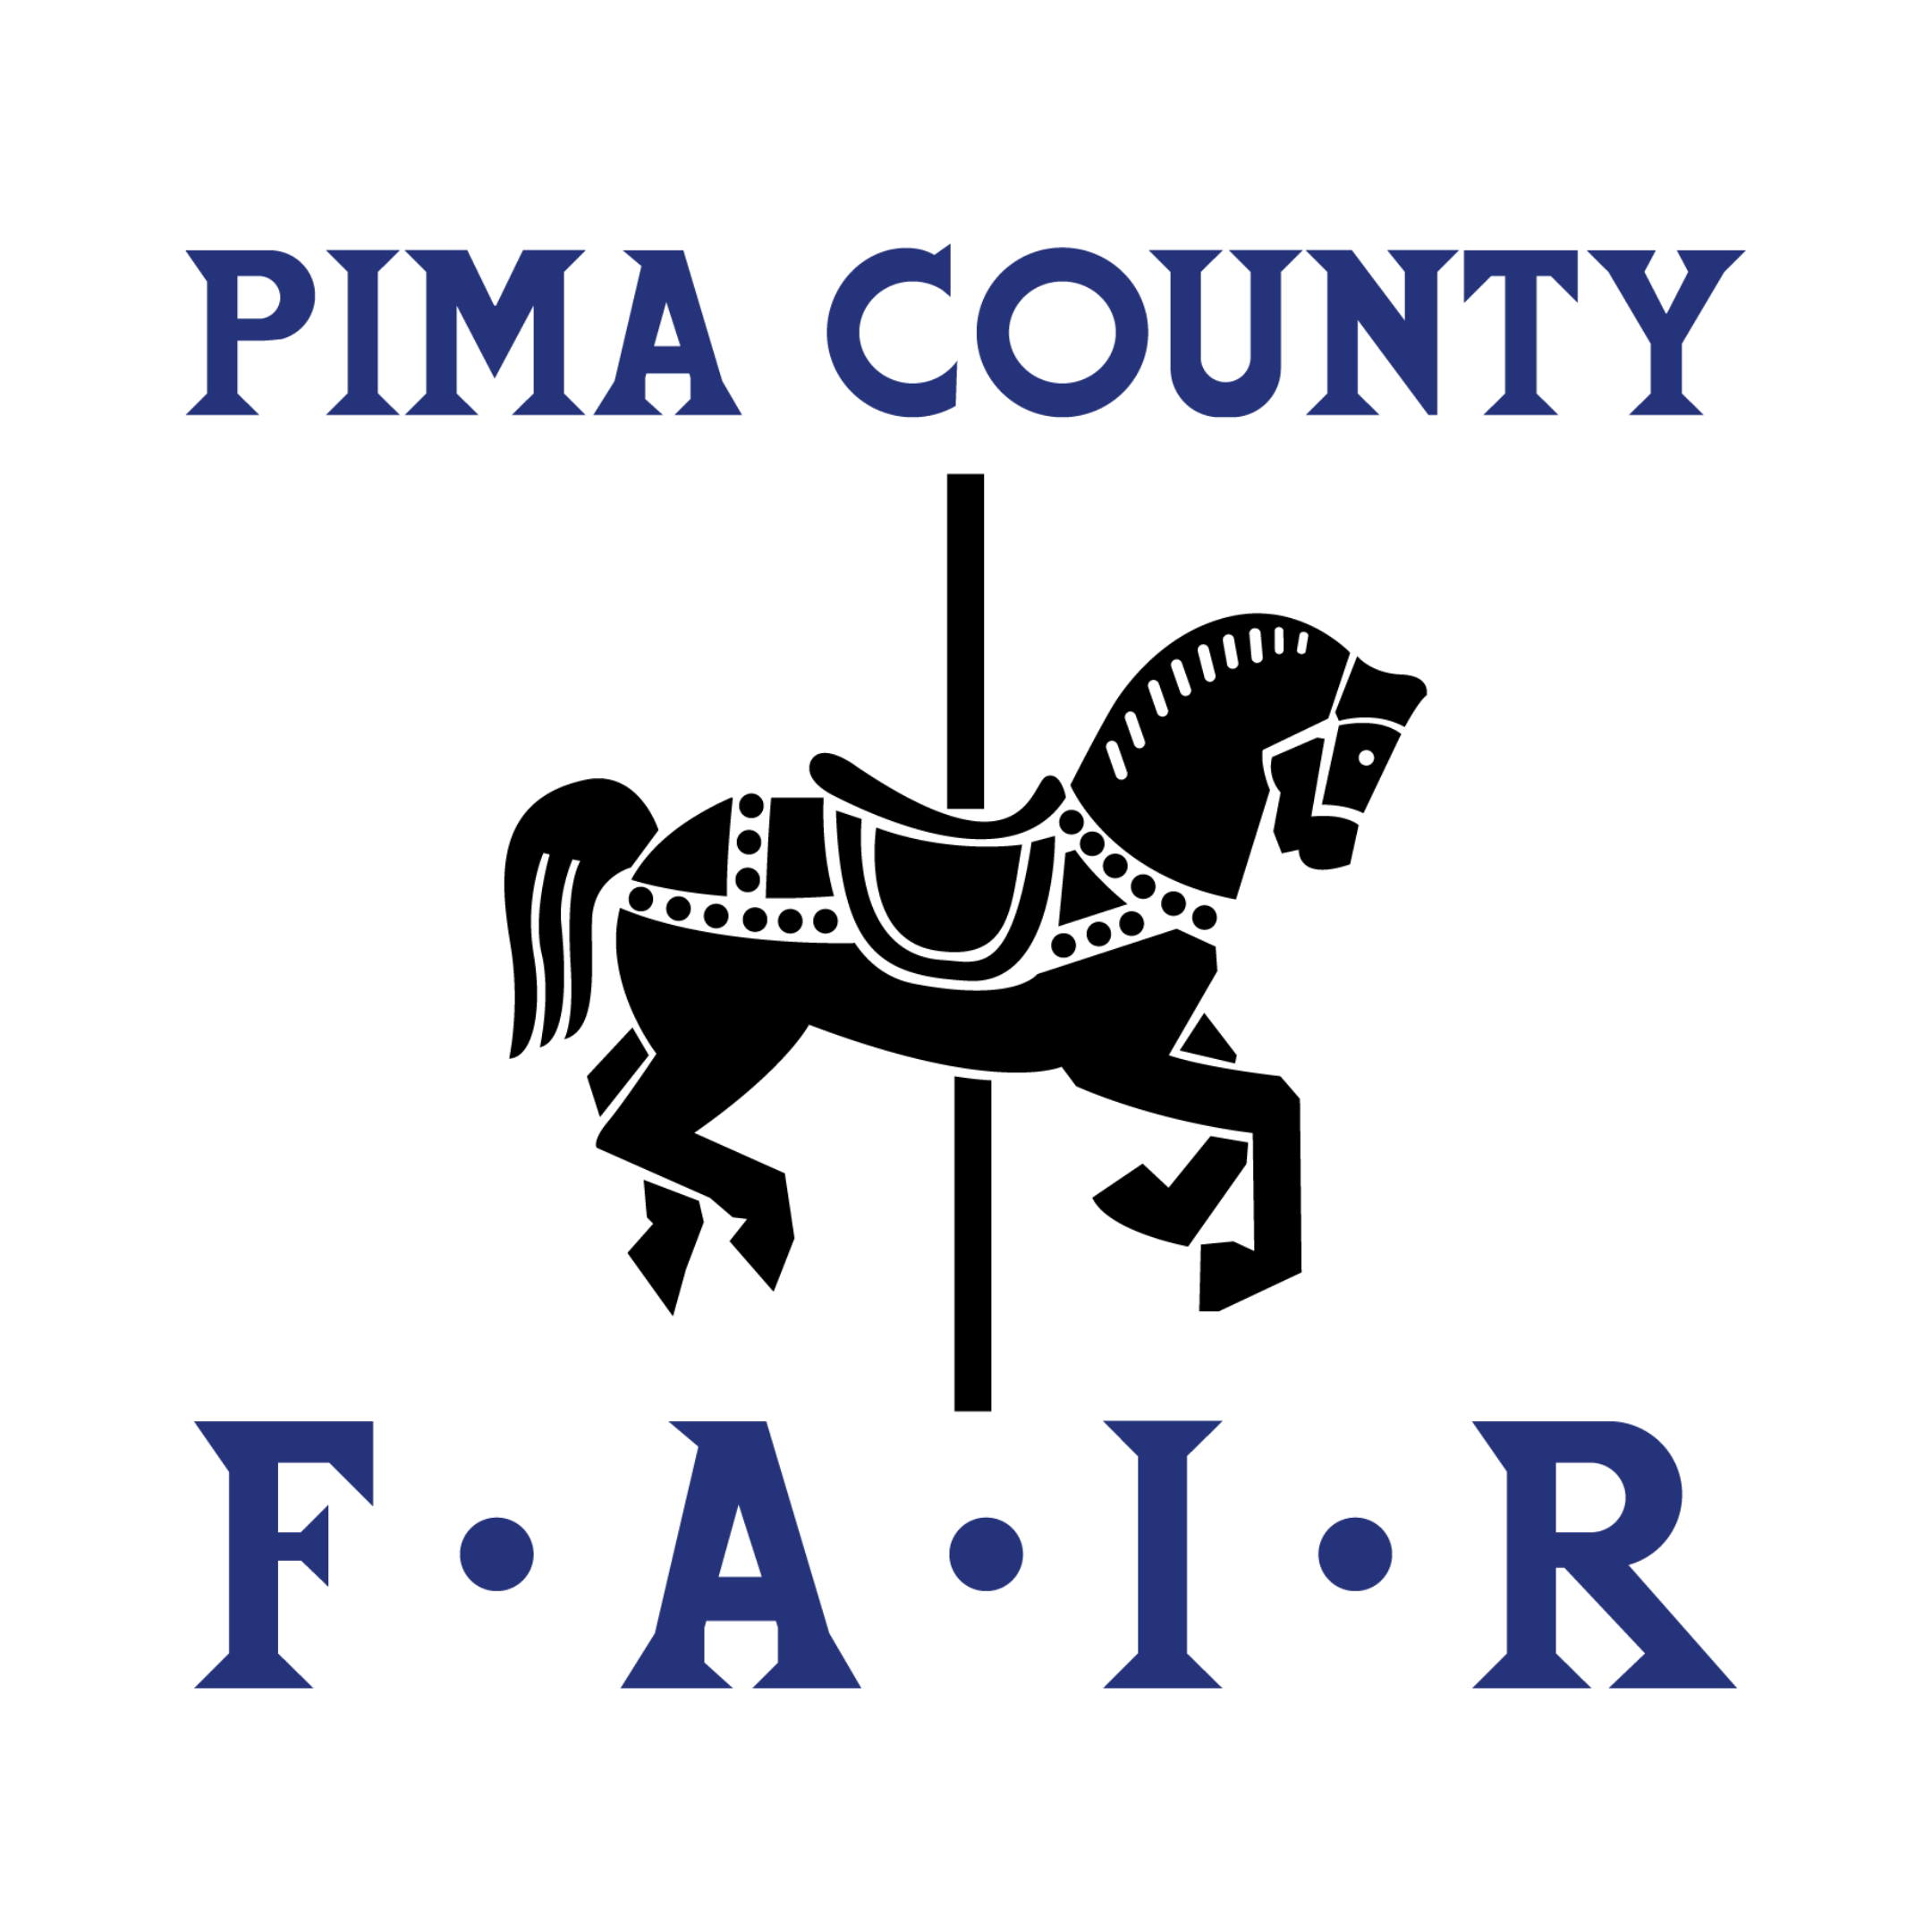
Yours for the Taking!

For Immediate Release – through April 27, 2025
Contact: Launa Rabago
Phone: 520-762-9100 x1014
Email: Office@PimaCountyFair.com
Website: www.PimaCountyFair.com

The Pima County Fair FOOD DRIVE
The Pima County Fair will proudly waive admission fees TWICE and host two food drives to help feed the hungry. Guests can bring in three (3) cans of food to receive free admission to the fair until noon; Sunday, April 20th and Sunday, April 27th. Collected food items will be donated to the Community Food Bank of Southern Arizona.

In addition, the fair will donate large portions of Pepsi-Cola
products that will be collected during the wristband day
promotions, Thursday, April 17th, Wednesday, April 23rd and
Thursday, April 24th to Gospel Rescue Mission of
Tucson, “where homelessness ends and lives are restored.”

