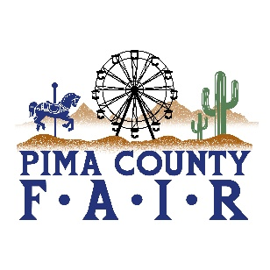
PIMA COUNTY FAIR 2026 OPEN & 4-H/FFA EVENTS
4/16 – 4/17 2026
THURSDAY, APRIL 16
9:00 am 4-H HORSE SHOW RANCH TRAIL
NORTH ARENA
9:00 am 4-H DOG SHOW-OBEDIENCE
BARN ARENA
7:00 pm 4-H HORSE RANCH SORTING
MANNY’S ARENA
FRIDAY, APRIL 17
9:00 am 4-H HORSE SHOW-ENGLISH
NORTH ARENA
9:00 am OPEN DAIRY GOAT SHOW-JR DOE
BARN ARENA
9:00 am OPEN POULTRY BREED SHOW
POULTRY AREA
NOON SHEEP SHEARING DEMO
RAMADA ARENA
5:00 pm 4-H DOG SHOWMANSHIP
BARN ARENA
5:00 pm 4-H HORSE-ROPING
MANNY’S ARENA
6:00 pm OPEN SWINE BOAR SHOW
RAMADA ARENA

