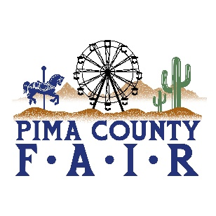
PIMA COUNTY FAIR 2026 OPEN & 4-H/FFA EVENTS
4/18/2026
SATURDAY APRIL 18
7:00 am 4-H ROCKETRY LAUNCH
MAIN/EAST PARKING
9:00 am 4-H HORSE-WESTERN
NORTH ARENA
9:00 am 4H/FFA CAVY SHOW-BREED
BARN ARENA
9:00 am OPEN DAIRY GOAT SHOW-SR DOE
BARN ARENA
10:00 am RABBIT BREED SHOW
BARN ARENA
NOON SHEEP SHEARING DEMOS
RAMADA ARENA AREA
2:00 pm 4H/FFA CAVY SHOW-
SHOWMANSHIP BARN ARENA
6:00 pm 4H HORSE SHOW
CHAMPION SHOWMANSHIP
BARN ARENA
6:00 pm SWINE CARCASS LIVE SHOW
RAMADA ARENA
7:00 pm 4H HORSE AWARDS CEREMONY
BARN ARENA

