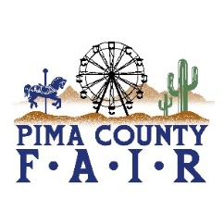
PIMA COUNTY FAIR 2026 OPEN & 4-H/FFA EVENTS April 19 - 21
SUNDAY, APRIL 19
9:00 am 4-H HORSE SHOW-GYMCHANA
MANNY’S ARENA
10:00 am 4H/FFA RABBIT SHOW- SHOWMANSHIP-BARN ARENA
NOON SHEEP SHEARING DEMO
RAMADA ARENA
MONDAY, APRIL 20
4:00 am—8:00 pm
CHECK IN OF ALL 4-H/FFA
ANIMAL SPECIES
MONDAY, APRIL 20
4:00 am—8:00 pm
CHECK IN OF ALL 4-H/FFA
ANIMAL SPECIES
TUESDAY, APRIL 21
9:00 am SHEEP SHOWMANSHIP SHOW
BREEDING SHEEP SHOW
MARKET SHOW
RAMADA ARENA
9:00 am POULTRY SHOWMANSHIP
BARN ARENA
9:00am PYGMY GOAT SHOWMANSHIP & BREED SHOW-BARN ARENA
5:00 pm SWINE MARKET SHOW
RAMADA ARENA

