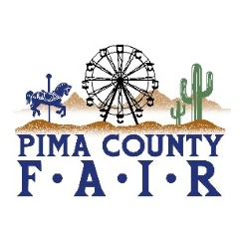
PIMA COUNTY FAIR 2026 OPEN & 4-H/FFA EVENTS
APRIL 24 – April 26
FRIDAY, APRIL 24
9:00 am DOG SHOW-AGILITY & RALLY
BARN ARENA
10:00 am LIVESTOCK JUDGING
RAMADA ARENA
2:00 pm BEEF FITTING CONTEST
BARN ARENA
5:00 pm SMALLSTOCK ROUND ROBIN SHOW
BARN ARENA
7:00 pm LARGESTOCK ROUND ROBIN SHOW
BARN ARENA
SATURDAY, APRIL 25
11:45 am LIVESTOCK AUCTION
RAMADA ARENA
SUNDAY, APRIL 26
10:30 am SMALLSTOCK AUCTION
RAMADA ARENA
4:30 pm EXHIBITORS MEETING &
RECOGNITIONS
6:00 pm CHECK OUT

