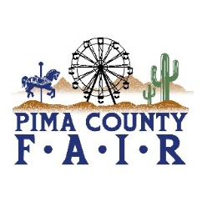
PIMA COUNTY FAIR 2026 OPEN & 4-H/FFA EVENTS April 23
THURSDAY, APRIL 23
9:00 am DAIRY GOAT SHOW-BREED &
SHOWMANSHIP
BARN ARENA
10:00 am BEEF SHOW-MARKET &
SHOWMANSHIP
RAMADA ARENA
2:00 pm PYGMY GOAT AGILITY
BARN ARENA
5:00 pm ADULT SWINE SHOWMANSHIP
6:30 pm ADULT BEEF SHOWMANSHIP
RAMADA ARENA
8-11 pm 4H/FFA DANCE-HALL OF CHAMPIONS
BROUGHT TO YOU BY:
IRONWOOD RANCHERS 4H CLUB

