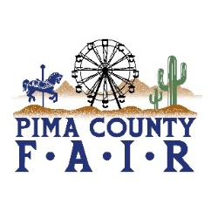
PIMA COUNTY FAIR 2026 OPEN & 4-H/FFA EVENTS
APRIL 22
WEDNESDAY, APRIL 22
9:00 am POULTRY SHOW BREED
BARN ARENA/POULTRY AREA
9:00 am PIGEON SHOW-SHOWMANSHIP &
BREED SHOW-BARN ARENA
9:00 am MARKET GOAT SHOWMANSHIP &
BREEDING DOE SHOW
MARKET GOAT SHOW
RAMADA ARENA
10:00 am DAIRY CATTLE BREED &
SHOWMANSHIP
BARN ARENA
3:00 pm SWINE GILT SHOW
RAMADA ARENA
5:00 pm SWINE SHOWMANSHIP
RAMADA ARENA

